Chapter 12. Building an E-Learning Platform

In the previous chapter, you learned the basics of the internationalization and localization of Django projects, adapting your project to meet the local formats and languages for your users.

In this chapter, you will start a new Django project that will consist of an elearning platform with your own content management system (CMS). Online learning platforms are a great example of applications that require tools for advanced content handling. You will learn how to create flexible data models that accommodate diverse data types and discover how to implement custom model functionalities that you can apply to your future Django projects.

In this chapter, you will learn how to:

- Create models for the CMS
- Create fixtures for your models and apply them
- Use model inheritance to create data models for polymorphic content
- Create custom model fields
- Order course contents and modules
- Build authentication views for the CMS

Functional overview
In previous chapters, diagrams at the start represented views, templates, and end-to-end functionalities. This chapter, however, shifts the focus to implementing model inheritance and creating custom model fields, topics not easily captured in our usual diagrams. Instead, you will see specific diagrams to illustrate these concepts throughout the chapter.
The source code for this chapter can be found at
https://github.com/PacktPublishing/Django-5-byexample/tree/main/Chapter12.

All the Python modules used in this chapter are included in the requirements.txt file in the source code that comes with this chapter. You can follow the instructions to install each Python module below, or you can install all the requirements at once with the command python -m pip install -r requirements.txt .
Setting up the e-learning project
Your final practical project will be an e-learning platform. First, create a virtual environment for your new project within the env/ directory with the following command:
python -m venv env/educa

If you are using Linux or macOS, run the following command to activate your virtual environment:
source env/educa/bin/activate

If you are using Windows, use the following command instead:
.\env\educa\Scripts\activate

Install Django in your virtual environment with the following command:
python -m pip install Django~=5.0.4

You are going to manage image uploads in your project, so you also need to install Pillow with the following command:
python -m pip install Pillow==10.3.0

Create a new project using the following command:
django-admin startproject educa

Enter the new educa directory and create a new application using the following commands:
cd educa
django-admin startapp courses

Edit the settings.py file of the educa project and add courses to the
INSTALLED_APPS setting, as follows. The new line is highlighted in bold:
INSTALLED_APPS = [
'courses.apps.CoursesConfig',
'django.contrib.admin',
'django.contrib.auth',
'django.contrib.contenttypes',
'django.contrib.sessions',
'django.contrib.messages',
'django.contrib.staticfiles',
]

The courses application is now active for the project. Next, we are going to prepare our project to serve media files and we will define the models for the courses and course contents.
Serving media files
Before creating the models for courses and course contents, we will prepare the project to serve media files. Course instructors will be able to upload media files to course content using the CMS that we will build. Therefore, we will configure the project to serve media files.

Edit the settings.py file of the project and add the following lines:
MEDIA_URL = 'media/'
MEDIA_ROOT = BASE_DIR / 'media'

This will enable Django to manage file uploads and serve media files.
MEDIA_URL is the base URL used to serve the media files uploaded by users. MEDIA_ROOT is the local path where they reside. Paths and URLs for files are built dynamically by prepending the project path or the media URL to them for portability.

Now, edit the main urls.py file of the educa project and modify the code, as follows. New lines are highlighted in bold:
from django.conf import settings
from django.conf.urls.static import static
from django.contrib import admin
from django.urls import path
urlpatterns = [
path('admin/', admin.site.urls),
]
if settings.DEBUG:
urlpatterns += static(
settings.MEDIA_URL, document_root=settings.MEDIA_ROOT
)

We have added the static() helper function to serve media files with the Django development server during development (that is, when the DEBUG setting is set to True ).


Remember that the static() helper function is suitable for
development but not for production use. Django is inefficient
at serving static files. Never serve your static files with the
Django development server in a production environment.
You will learn how to serve static files in a production
environment in Chapter 17, Going Live.

The project is now ready to serve media files. Let’s create the models for the courses and course contents.

Building the course models
Your e-learning platform will offer courses on various subjects. Each course will be divided into a configurable number of modules, and each module will contain a configurable number of contents. The contents will be of various types: text, files, images, or videos. The following example shows what the data structure of your course catalog will look like:
Subject 1
Course 1
Module 1
Content 1 (image)
Content 2 (text)
Module 2
Content 3 (text)
Content 4 (file)
Content 5 (video)
...

Let’s build the course models. Edit the models.py file of the courses application and add the following code to it:
from django.contrib.auth.models import User
from django.db import models
class Subject(models.Model):
title = models.CharField(max_length=200)
slug = models.SlugField(max_length=200, unique=True)
class Meta:
ordering = ['title']
def __str__(self):
return self.title
class Course(models.Model):
owner = models.ForeignKey(
User,
related_name='courses_created',
on_delete=models.CASCADE
)
subject = models.ForeignKey(
Subject,
related_name='courses',
on_delete=models.CASCADE
)
title = models.CharField(max_length=200)
slug = models.SlugField(max_length=200, unique=True)
overview = models.TextField()
created = models.DateTimeField(auto_now_add=True)
class Meta:
ordering = ['-created']
def __str__(self):
return self.title
class Module(models.Model):
course = models.ForeignKey(
Course, related_name='modules', on_delete=models.CASCADE
)
title = models.CharField(max_length=200)
description = models.TextField(blank=True)
def __str__(self):
return self.title

These are the initial Subject , Course , and Module models. The Course model fields are as follows:

- owner : The instructor who created this course.

- subject : The subject that this course belongs to. It is a ForeignKey field that points to the

- Subject model.

- title : The title of the course.

- slug : The slug of the course. This will be used in URLs later.

- overview : A TextField column to store an overview of the course.

- created : The date and time when the course was created. It will be automatically set by Django when creating new objects because of auto_now_add=True .

Each course is divided into several modules. Therefore, the Module model contains a ForeignKey field that points to the Course model.

Open the shell and run the following command to create the initial migration for this application:
python manage.py makemigrations

You will see the following output:
Migrations for 'courses':
courses/migrations/0001_initial.py:
- Create model Course
- Create model Module
- Create model Subject
- Add field subject to course

Then, run the following command to apply all migrations to the database:
python manage.py migrate

You should see output that includes all applied migrations, including those of Django. The output will contain the following line:
Applying courses.0001_initial... OK

The models of your courses application have been synced with the database. Next, we are going to add the course models to the administration site.

Registering the models in the administration site
Let’s register the course models on the administration site so that we can manage the data easily. Edit the admin.py file inside the courses application directory and add the following code to it:
from django.contrib import admin
from .models import Subject, Course, Module
@admin.register(Subject)
class SubjectAdmin(admin.ModelAdmin):
list_display = ['title', 'slug']
prepopulated_fields = {'slug': ('title',)}
class ModuleInline(admin.StackedInline):
model = Module
@admin.register(Course)
class CourseAdmin(admin.ModelAdmin):
list_display = ['title', 'subject', 'created']
list_filter = ['created', 'subject']
search_fields = ['title', 'overview']
prepopulated_fields = {'slug': ('title',)}
inlines = [ModuleInline]

The models for the courses application are now registered on the administration site. Remember that you use the @admin.register() decorator to register models on the administration site.

In the next section, you will learn how to create initial data to populate your models.

Using fixtures to provide initial data for models
Sometimes, you might want to prepopulate your database with hardcoded data. This is useful for automatically including initial data in the project setup, instead of having to add it manually. Django comes with a simple way to load and dump data from the database into files that are called fixtures. Django supports fixtures in JSON, XML, or YAML formats. The structure of a fixture closely resembles the API representation of a model, making it straightforward to translate data between internal database formats and external applications. You are going to create a fixture to include several
initial Subject objects for your project.

First, create a superuser using the following command:
python manage.py createsuperuser

Then, run the development server using the following command:
python manage.py runserver

Open http://127.0.0.1:8000/admin/courses/subject/ in your browser.
Create several subjects using the administration site. The change list page should look as follows:
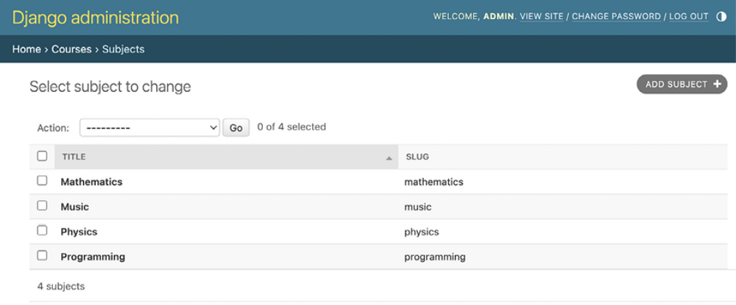
Figure 12.1: The subject change list view on the administration site

Run the following command from the shell:
python manage.py dumpdata courses --indent=2

You will see an output similar to the following:
[
{
"model": "courses.subject",
"pk": 1,
"fields": {
"title": "Mathematics",
"slug": "mathematics"
}
},
{
"model": "courses.subject",
"pk": 2,
"fields": {
"title": "Music",
"slug": "music"
}
},
{
"model": "courses.subject",
"pk": 3,
"fields": {
"title": "Physics",
"slug": "physics"
}
},
{
"model": "courses.subject",
"pk": 4,
"fields": {
"title": "Programming",
"slug": "programming"
}
}
]

The dumpdata command dumps data from the database into the standard output, serialized in JSON format by default. The resulting data structure includes information about the model and its fields for Django to be able to load it into the database.

You can limit the output to the models of an application by providing the application names to the command or specifying single models for outputting data using the app.Model format.

You can also specify the format using the --format flag. By default, dumpdata outputs the serialized data to the standard output. However, you can indicate an output file using the --output flag, which allows you to store the output. The --indent flag allows you to specify indentations. For more information on dumpdata parameters, run python manage.py dumpdata --help .

Save this dump to a fixtures file in a new fixtures/ directory in the courses application using the following commands:
mkdir courses/fixtures
python manage.py dumpdata courses --indent=2 --output=courses/fix

Run the development server and use the administration site to remove the subjects you created, as shown in Figure 12.2:
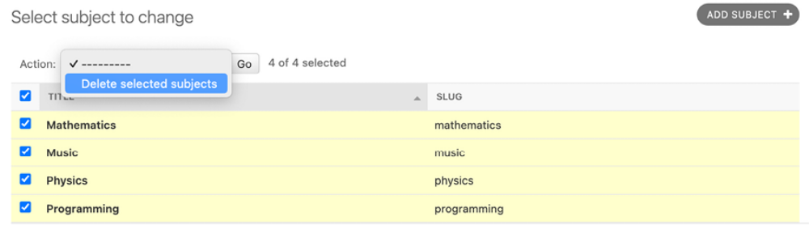
Figure 12.2: Deleting all existing subjects

After deleting all subjects, load the fixture into the database using the following command:
python manage.py loaddata subjects.json

All Subject objects included in the fixture are loaded into the database again:
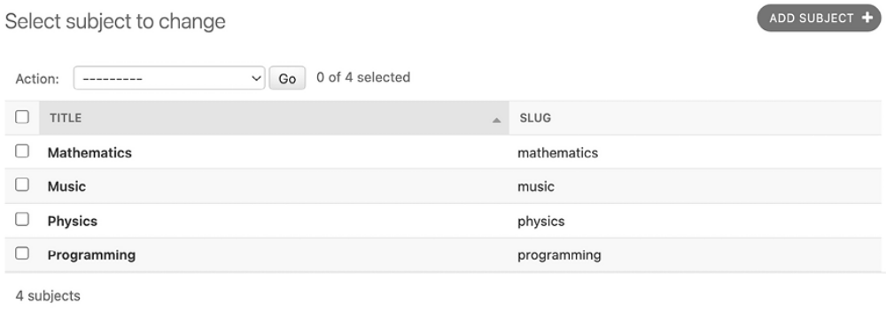
Figure 12.3: Subjects from the fixture are now loaded into the database

By default, Django looks for files in the fixtures/ directory of each application, but you can specify the complete path to the fixture file for the loaddata command. You can also use the FIXTURE_DIRS setting to tell Django about additional directories to look in for fixtures.


Fixtures are not only useful for setting up initial data but also
for providing sample data for your application or data
required for your tests. You can also use fixtures to populate
necessary data for production environments.

You can read about how to use fixtures for testing at
https://docs.djangoproject.com/en/5.0/topics/testing/tools/#fixture-loading.

If you want to load fixtures in model migrations, look at Django’s documentation about data migrations. You can find the documentation for migrating data at
https://docs.djangoproject.com/en/5.0/topics/migrations/#data-migrations.

You have created the models to manage course subjects, courses, and course modules. Next, you will create models to manage different types of module content.

Creating models for polymorphic content
You plan to add different types of content to the course modules, such as text, images, files, and videos. Polymorphism is the provision of a single interface to entities of different types. You need a versatile data model that allows you to store diverse content that is accessible through a single interface. In Chapter 7, Tracking User Actions, you learned about the convenience of using generic relations to create foreign keys that can point to the objects of any model. You are going to create a Content model that represents the modules’ contents and define a generic relation to associate any object with the content object.
Edit the models.py file of the courses application and add the following imports:
from django.contrib.contenttypes.fields import GenericForeignKey
from django.contrib.contenttypes.models import ContentType

Then, add the following code to the end of the file:
class Content(models.Model):
module = models.ForeignKey(
Module,
related_name='contents',
on_delete=models.CASCADE
)
content_type = models.ForeignKey(
ContentType,
on_delete=models.CASCADE
)
object_id = models.PositiveIntegerField()
item = GenericForeignKey('content_type', 'object_id')
T
his is the Content model. A module contains multiple contents, so you define a ForeignKey field that points to the Module model. You can also set up a generic relation to associate objects from different models that represent different types of content. Remember that you need three different fields to set up a generic relation. In your Content model, these are:

- content_type : A ForeignKey field to the ContentType model

- object_id : A PositiveIntegerField to store the primary key of the related object

- item : A GenericForeignKey field to the related object combining the two previous fields

Only the content_type and object_id fields have a corresponding column in the database table of this model. The item field allows you to retrieve or set the related object directly, and its functionality is built on top of the other two fields.

You are going to use a distinct model for each type of content; text, image, video, and document. Your Content models will share some common fields but they will vary in the specific data that they store. For example, for text content, you will store the actual text, but for video content, you will store the video URL. To accomplish this, you will need to employ model inheritance. We will dive into the options that Django offers for model
inheritance before building our Content models.

Using model inheritance
Django supports model inheritance. It works in a similar way to standard class inheritance in Python. If you are not familiar with class inheritance, it involves defining a new class that inherits methods and properties from an existing class. This facilitates code reusability and can simplify the creation of related classes. You can read more about class inheritance at https://docs.python.org/3/tutorial/classes.html#inheritance.
Django offers the following three options to use model inheritance:

- Abstract models: Useful when you want to put some common information into several models

- Multi-table model inheritance: Applicable when each model in the hierarchy is considered a complete model by itself

- Proxy models: Useful when you need to change the behavior of a model, for example, by including additional methods, changing the default manager, or using different meta options

Let’s take a closer look at each of them.
Abstract models
An abstract model is a base class in which you define the fields you want to include in all child models. Django doesn’t create any database tables for abstract models. A database table is created for each child model, including the fields inherited from the abstract class and the ones defined in the child model.

To mark a model as abstract, you need to include abstract=True in its Meta class. Django will recognize that it is an abstract model and will not create a database table for it. To create child models, you just need to subclass the abstract model.

The following example shows an abstract BaseContent model and a child
Text model:
from django.db import models
class BaseContent(models.Model):
title = models.CharField(max_length=100)
created = models.DateTimeField(auto_now_add=True)
class Meta:
abstract = True
class Text(BaseContent):
body = models.TextField()

In this case, Django would create a table for the Text model only, including the title , created, and body fields.
Figure 12.4 shows the models and associated database tables for the code example provided:
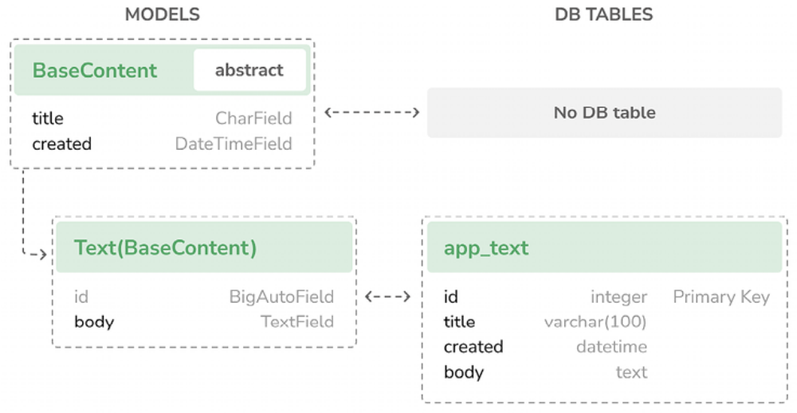
Figure 12.4: Sample models and database tables for inheritance using abstract models

Next, we are going to learn about a different model inheritance approach, where multiple database tables are created.

Multi-table model inheritance
In multi-table inheritance, each model corresponds to a database table. Django creates a OneToOneField field for the relationship between the child model and its parent model. To use multi-table inheritance, you have to subclass an existing model. Django will create a database table for both the original model and the sub-model. The following example shows multi-table inheritance:
from django.db import models
class BaseContent(models.Model):
title = models.CharField(max_length=100)
created = models.DateTimeField(auto_now_add=True)
class Text(BaseContent):
body = models.TextField()

Django will include an automatically generated OneToOneField field in the Text model that points to the BaseContent model. The name for this field is basecontent_ptr , where ptr stands for pointer. A database table is created for each model.
Figure 12.5 shows the models and associated database tables for the multitable model inheritance code example provided:
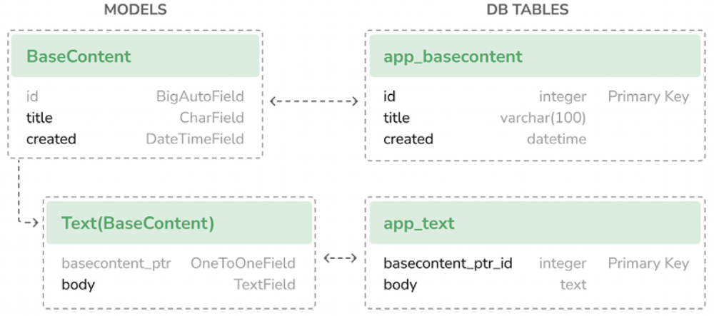
Figure 12.5: Sample models and database tables for multi-table model inheritance

Next, we are going to learn about another model inheritance approach, where multiple models serve as a proxy to a single database table.

Proxy models
A proxy model changes the behavior of a model. Both models operate on the database table of the original model. This allows you to customize behavior for different models without creating a new database table, creating different versions of the same model that are tailored for different purposes. To create a proxy model, add proxy=True to the Meta class of the model. The following example illustrates how to create a proxy model:
from django.db import models
from django.utils import timezone
class BaseContent(models.Model):
title = models.CharField(max_length=100)
created = models.DateTimeField(auto_now_add=True)
class OrderedContent(BaseContent):
class Meta:
proxy = True
ordering = ['created']
def created_delta(self):
return timezone.now() - self.created

Here, you define an OrderedContent model that is a proxy model for the Content model. This model provides a default ordering for QuerySets and an additional created_delta() method. Both models, Content and OrderedContent , operate on the same database table, and objects are accessible via the ORM through either model.
Figure 12.6 shows the models and associated database tables for the proxy model inheritance code example provided:
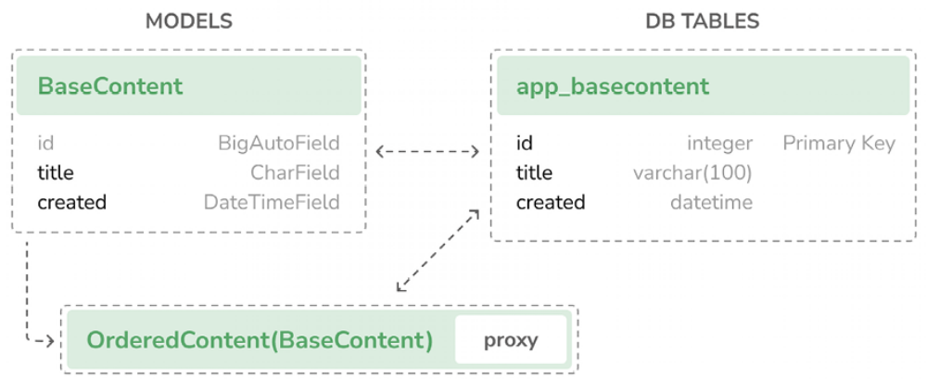
Figure 12.6: Sample models and database tables for inheritance using proxy models

You have now become familiar with the three types of model inheritance.
For additional information on model inheritance, you can visit
https://docs.djangoproject.com/en/5.0/topics/db/models/#model-inheritance. Now, we will apply model inheritance in practice by using a base abstract model to develop models for various content types.

Creating the Content models
Let’s use model inheritance to implement polymorphic models. You will create a versatile data model that enables storing diverse content accessible through a unified interface. The ideal approach for this use case is to create an abstract base model that is then extended by models – each designed to store a particular type of data: text, image, video, and file. This flexible approach will equip you with the tools needed for scenarios where polymorphism is required.

The Content model of your courses application contains a generic relation to associate different types of content with it. You will create a different model for each type of content. All Content models will have some fields in common and additional fields to store custom data. You are going to create an abstract model that provides the common fields for all Content models.

Edit the models.py file of the courses application and add the following
code to it:
class ItemBase(models.Model):
owner = models.ForeignKey(User,
related_name='%(class)s_related',
on_delete=models.CASCADE
)
title = models.CharField(max_length=250)
created = models.DateTimeField(auto_now_add=True)
updated = models.DateTimeField(auto_now=True)
class Meta:
abstract = True
def __str__(self):
return self.title
class Text(ItemBase):
content = models.TextField()
class File(ItemBase):
file = models.FileField(upload_to='files')
class Image(ItemBase):
file = models.FileField(upload_to='images')
class Video(ItemBase):
url = models.URLField()

In this code, you define an abstract model named ItemBase . Therefore, you set abstract=True in its Meta class.

In this model, you define the owner , title , created , and updated fields. These common fields will be used for all types of content. The owner field allows you to store which user created the content. Since this field is defined in an abstract class, you need a different related_name for each sub-model. Django allows you to specify a placeholder for the
model class name in the related_name attribute as %(class)s . By doing so, the related_name for each child model will be generated automatically.

Since you are using '%(class)s_related' as the related_name , the reverse relationship for child models will be text_related , file_related , image_related , and video_related , respectively.

You have defined four different Content models that inherit from the

- ItemBase abstract model. They are as follows:

- Text : To store text content

- File : To store files, such as PDFs

- Image : To store image files

- Video : To store videos; you use a URLField field to provide a video

URL in order to embed it Each child model contains the fields defined in the ItemBase class in addition to its own fields. A database table will be created for the Text , File , Image , and Video models, respectively. There will be no database table associated with the ItemBase model since it is an abstract model.
Figure 12.7 shows the Content models and the associated database tables:
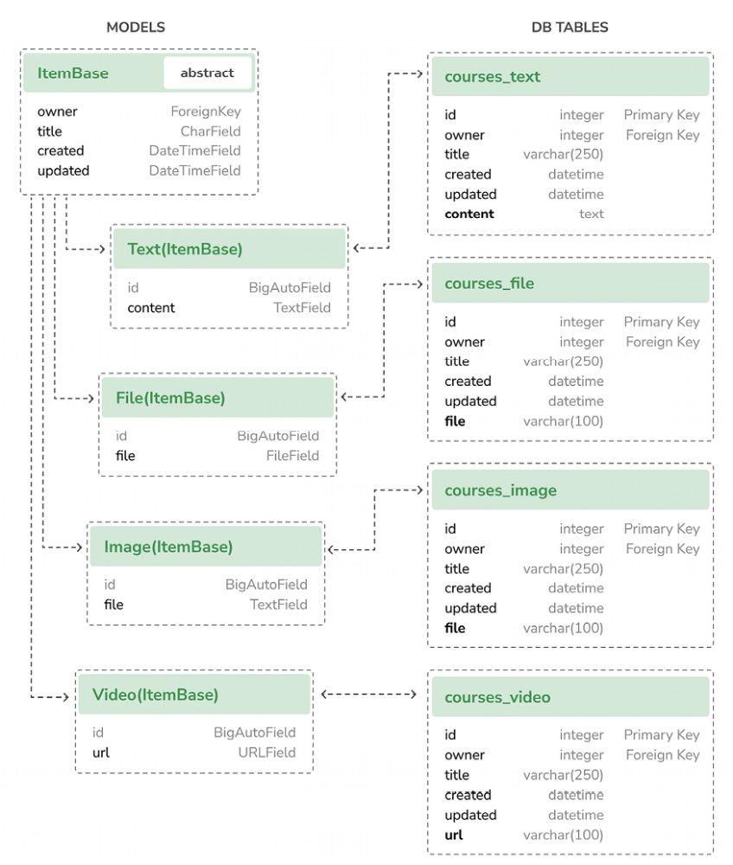
Figure 12.7: Content models and associated database tables

Edit the Content model you created previously and modify its content_type field, as follows:
content_type = models.ForeignKey(
ContentType,
on_delete=models.CASCADE,
limit_choices_to={
'model__in':('text', 'video', 'image', 'file')
}
)

You add a limit_choices_to argument to limit the ContentType objects that can be used for the generic relation. You use the model__in field lookup to filter the query to the ContentType objects with a model attribute that is 'text' , 'video' , 'image' , or 'file' .

Let’s create a migration to include the new models you have added. Run the following command from the command line:
python manage.py makemigrations

You will see the following output:
Migrations for 'courses':
courses/migrations/0002_video_text_image_file_content.py
- Create model Video
- Create model Text
- Create model Image
- Create model File
- Create model Content

Then, run the following command to apply the new migration:
python manage.py migrate

The output you see should end with the following line:
Applying courses.0002_video_text_image_file_content... OK

You have created models that are suitable for adding diverse content to the course modules. However, there is still something missing in your models: the course modules and contents should follow a particular order. You need a field that allows you to order them easily.

Creating custom model fields
Django comes with a complete collection of model fields that you can use to build your models. However, you can also create your own model fields to store custom data or alter the behavior of existing fields. Custom fields allow you to store unique data types, implement custom validations, encapsulate complex data logic related to the field, or define specific rendering forms using custom widgets.

You need a field that allows you to define an order for the objects. An easy way to specify an order for objects using existing Django fields is by adding a PositiveIntegerField to your models. Using integers, you can easily specify the order of the objects. You can create a custom order field that inherits from PositiveIntegerField and provides additional behavior.

There are two relevant functionalities that you will build into your order field:
- Automatically assign an order value when no specific order is provided: When saving a new object with no specific order, your field should automatically assign the number that comes after the last existing ordered object. If there are two objects with orders 1 and 2 respectively, when saving a third object, you should automatically assign order 3 to it if no specific order has been provided.

- Order objects with respect to other fields: Course modules will be ordered with respect to the course they belong to and module contents with respect to the module they belong to.

Create a new fields.py file inside the courses application directory and
add the following code to it:
from django.core.exceptions import ObjectDoesNotExist
from django.db import models
class OrderField(models.PositiveIntegerField):
def __init__(self, for_fields=None, *args, **kwargs):
self.for_fields = for_fields
super().__init__(*args, **kwargs)
def pre_save(self, model_instance, add):
if getattr(model_instance, self.attname) is None:
# no current value
try:
qs = self.model.objects.all()
if self.for_fields:
# filter by objects with the same field valu
# for the fields in "for_fields"
query = {
field: getattr(model_instance, field)
for field in self.for_fields
}
qs = qs.filter(**query)
# get the order of the last item
last_item = qs.latest(self.attname)
value = getattr(last_item, self.attname) + 1
except ObjectDoesNotExist:
value = 0
setattr(model_instance, self.attname, value)
return value
else:
return super().pre_save(model_instance, add)

This is the custom OrderField . It inherits from the PositiveIntegerField field provided by Django. Your OrderField field takes an optional for_fields parameter, which allows you to indicate the fields used to order the data.

Your field overrides the pre_save() method of the PositiveIntegerField field, which is executed before saving the field to the database. In this method, you perform the following actions:
1. You check whether a value already exists for this field in the model instance. You use self.attname , which is the attribute name given to the field in the model. If the attribute’s value is different from None , you calculate the order you should give it as follows:
a. You build a QuerySet to retrieve all objects for the field’s model. You retrieve the model class the field belongs to by accessing self.model .

b. If there are any field names in the for_fields attribute of the field, you filter the QuerySet by the current value of the model fields in for_fields . By doing so, you calculate the order with respect to the given fields.

c. You retrieve the object with the highest order with last_item =qs.latest(self.attname) from the database. If no object is found,you assume this object is the first one and assign order 0 to it.

d. If an object is found, you add 1 to the highest order found.

e. You assign the calculated order to the field’s value in the model instance using setattr() and return it.

2. If the model instance has a value for the current field, you use it instead of calculating it.


When you create custom model fields, make them generic.
Avoid hardcoding data that depends on a specific model or
field. Your field should work in any model.

You can find more information about writing custom model fields at
https://docs.djangoproject.com/en/5.0/howto/custommodel-fields/.
Next, we are going to use the custom field we have created.

Adding ordering to Module and Content objects
Let’s add the new field to your models. Edit the models.py file of the courses application, and import the OrderField class and a field to the Module model, as follows:
from .fields import OrderField
class Module(models.Model):
# ...
order = OrderField(blank=True, for_fields=['course'])

You name the new field order and specify that the ordering is calculated with respect to the course by setting for_fields=['course'] . This means that the order for a new module will be assigned by adding 1 to the last module of the same Course object.

Now, you can edit the __str__() method of the Module model to include its order, as follows:
class Module(models.Model):
# ...
def __str__(self):
return f'{self.order}. {self.title}'

Module contents also need to follow a particular order. Add an OrderField field to the Content model, as follows:
class Content(models.Model):
# ...
order = OrderField(blank=True, for_fields=['module'])

This time, you specify that the order is calculated with respect to the module field.

Finally, let’s add a default ordering for both models. Add the following Meta class to the Module and Content models:
class Module(models.Model):
# ...
class Meta:
ordering = ['order']
class Content(models.Model):
# ...
class Meta:
ordering = ['order']

The Module and Content models should now look as follows:
class Module(models.Model):
course = models.ForeignKey(
Course, related_name='modules', on_delete=models.CASCADE
)
title = models.CharField(max_length=200)
description = models.TextField(blank=True)
order = OrderField(blank=True, for_fields=['course'])
class Meta:
ordering = ['order']
def __str__(self):
return f'{self.order}. {self.title}'
class Content(models.Model):
module = models.ForeignKey(
Module,
related_name='contents',
on_delete=models.CASCADE
)
content_type = models.ForeignKey(
ContentType,
on_delete=models.CASCADE,
limit_choices_to={
'model__in':('text', 'video', 'image', 'file')
}
)
object_id = models.PositiveIntegerField()
Item = GenericForeignKey('content_type', 'object_id')
order = OrderField(blank=True, for_fields=['module'])
class Meta:
ordering = ['order']

Let’s create a new model migration that reflects the new order fields. Open the shell and run the following command:
python manage.py makemigrations courses

You will see the following output:
It is impossible to add a non-nullable field 'order' to content w
Please select a fix:
1) Provide a one-off default now (will be set on all existing ro
2) Quit and manually define a default value in models.py.
Select an option:

Django is telling you that you have to provide a default value for the new order field for existing rows in the database. If the field includes null=True , it accepts null values and Django creates the migration automatically instead of asking for a default value. You can specify a default value or cancel the migration and add a default attribute to the order field in the models.py file before creating the migration.

Enter 1 and press Enter to provide a default value for existing records. You will see the following output:
Please enter the default value as valid Python.
The datetime and django.utils.timezone modules are available, so
Type 'exit' to exit this prompt
>>>
Enter 0 so that this is the default value for existing records and press Enter. Django will ask you for a default value for the Module model, too. Choose the first option and enter 0 as the default value again. Finally, you will see an output similar to the following one:
Migrations for 'courses':
courses/migrations/0003_alter_content_options_alter_module_option
- Change Meta options on content
- Change Meta options on module
- Add field order to content
- Add field order to module

Then, apply the new migrations with the following command:
python manage.py migrate

The output of the command will inform you that the migration was successfully applied, as follows:
Applying courses.0003_alter_content_options_alter_module_options_

Let’s test your new field. Open the shell with the following command:
python manage.py shell

Create a new course, as follows:
>>> from django.contrib.auth.models import User
>>> from courses.models import Subject, Course, Module
>>> user = User.objects.last()
>>> subject = Subject.objects.last()
>>> c1 = Course.objects.create(subject=subject, owner=user, title

You have created a course in the database. Now, you will add modules to the course and see how their order is automatically calculated. You create an initial module and check its order:
>>> m1 = Module.objects.create(course=c1, title='Module 1')
>>> m1.order
0

OrderField sets its value to 0 since this is the first Module object created for
the given course. You can create a second module for the same course:
>>> m2 = Module.objects.create(course=c1, title='Module 2')
>>> m2.order
1
OrderField calculates the next order value, adding 1 to the highest order for existing objects. Let’s create a third module, forcing a specific order:
>>> m3 = Module.objects.create(course=c1, title='Module 3', order
>>> m3.order
5

If you provide a custom order when creating or saving an object, OrderField
will use that value instead of calculating the order.

Let’s add a fourth module:
>>> m4 = Module.objects.create(course=c1, title='Module 4')
>>> m4.order
6

The order for this module has been automatically set. Your OrderField field does not guarantee that all order values are consecutive. However, it respects existing order values and always assigns the next order based on the highest existing order.

create a second course and add a module to it:
>>> c2 = Course.objects.create(subject=subject, title='Course 2',
>>> m5 = Module.objects.create(course=c2, title='Module 1')
>>> m5.order
0

To calculate the new module’s order, the field only takes into consideration existing modules that belong to the same course. Since this is the first module of the second course, the resulting order is 0 . This is because you specified for_fields=['course'] in the order field of the Module model.

Congratulations! You have successfully created your first custom model field. Next, you are going to create an authentication system for the CMS.

Adding authentication views
Now that you have created a polymorphic data model, you are going to build a CMS to manage the courses and their contents. The first step is to add an authentication system for the CMS.

Adding an authentication system
You are going to use Django’s authentication framework for users to authenticate to the e-learning platform. You learned how to use the Django authentication views in Chapter 4, Building a Social Website. Both instructors and students will be instances of Django’s User model, so they will be able to log in to the site using the authentication views of
django.contrib.auth .

Edit the main urls.py file of the educa project and include the login and
logout views of Django’s authentication framework:
from django.conf import settings
from django.conf.urls.static import static
from django.contrib import admin
from django.contrib.auth import views as auth_views
from django.urls import path
urlpatterns = [
path(
'accounts/login/', auth_views.LoginView.as_view(), name='login'
),
path(
'accounts/logout/',
auth_views.LogoutView.as_view(),
name='logout'
),
path('admin/', admin.site.urls),
]
if settings.DEBUG:
urlpatterns += static(
settings.MEDIA_URL, document_root=settings.MEDIA_ROOT
)

Next, we are going to create the authentication templates for the Django authentication views.

Creating the authentication templates
Create the following file structure inside the courses application directory:
templates/
base.html
registration/
login.html
logged_out.html

Before building the authentication templates, you need to prepare the base template for your project. Edit the base.html template file and add the following content to it:
{% load static %}
<!DOCTYPE html>
<html>
<head>
<meta charset="utf-8" />
<title>{% block title %}Educa{% endblock %}</title>
<link href="{% static "css/base.css" %}" rel="stylesheet">
</head>
<body>
<div id="header">
<a href="/" class="logo">Educa</a>
<ul class="menu">
{% if request.user.is_authenticated %}
<li>
<form action="{% url "logout" %}" method="post">
<button type="submit">Sign out</button>
</form>
</li>
{% else %}
<li><a href="{% url "login" %}">Sign in</a></li>
{% endif %}
</ul>
</div>
<div id="content">
{% block content %}
{% endblock %}
</div>
<script>
document.addEventListener('DOMContentLoaded', (event) => {
// DOM loaded
{% block domready %}
{% endblock %}
})
</script>
</body>
</html>

This is the base template that will be extended by the rest of the templates. In this template, you define the following blocks:

- title : The block for other templates to add a custom title for each page.

- content : The main block for content. All templates that extend the base template should add content to this block.

- domready : Located inside the JavaScript event listener for the

- DOMContentLoaded event. This allows you to execute code when the Document Object Model (DOM) has finished loading.

The CSS styles used in this template are located in the static/ directory of the courses application in the code that comes with this chapter. Copy the static/ directory into the same directory of your project to use them. You can find the contents of the directory at
https://github.com/PacktPublishing/Django-5-by Example/tree/main/Chapter12/educa/courses/static.

Edit the registration/login.html template and add the following code to it:
{% extends "base.html" %}
{% block title %}Log-in{% endblock %}
{% block content %}
<h1>Log-in</h1>
<div class="module">
{% if form.errors %}
<p>Your username and password didn't match. Please try aga
{% else %}
<p>Please, use the following form to log-in:</p>
{% endif %}
<div class="login-form">
<form action="{% url 'login' %}" method="post">
{{ form.as_p }}
{% csrf_token %}
<input type="hidden" name="next" value="{{ next }}" />
<p><input type="submit" value="Log-in"></p>
</form>
</div>
</div>
{% endblock %}

This is a standard login template for Django’s login view.
Edit the registration/logged_out.html template and add the following code to it:
{% extends "base.html" %}
{% block title %}Logged out{% endblock %}
{% block content %}
<h1>Logged out</h1>
<div class="module">
<p>
You have been successfully logged out.
You can <a href="{% url "login" %}">log-in again</a>.
</p>
</div>
{% endblock %}

This is the template that will be displayed to the user after logging out. Run the development server with the following command:
python manage.py runserver

Open http://127.0.0.1:8000/accounts/login/ in your browser. You should see the login page:
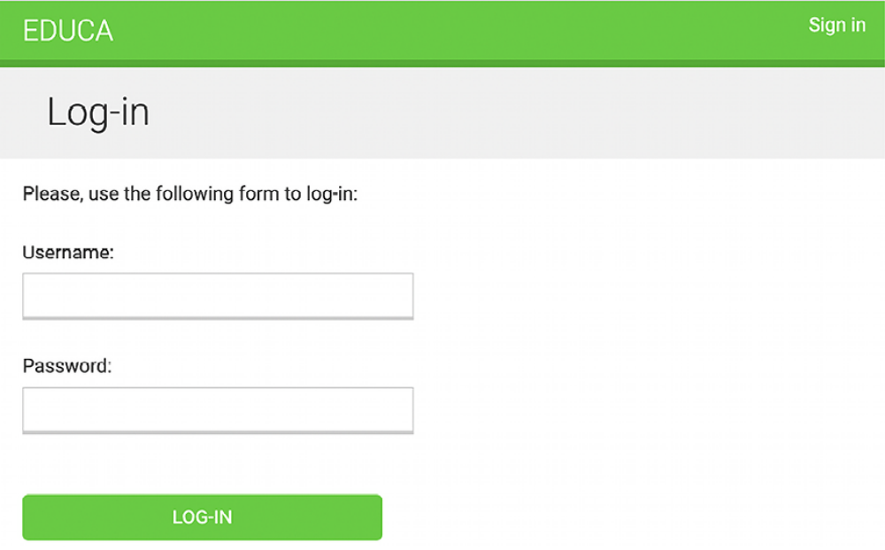
Figure 12.8: The account login page

Log in with the superuser credentials. You will be redirected to the URL http://127.0.0.1:8000/accounts/profile/ , which is the default redirect URL for the auth module. You will get an HTTP 404 response because the given URL doesn’t exist yet. The URL to redirect users after a successful login is defined in the setting LOGIN_REDIRECT_URL . You will define a custom redirect URL in Chapter 14, Rendering and Caching Content.

Open http://127.0.0.1:8000/accounts/login/ again in your browser. Now, you should see the Sign out button in the header of the page. Click on the Sign out button. You should see the Logged out page now, as shown in Figure 12.9:

Figure 12.9: The account Logged out page

You have successfully created an authentication system for the CMS.
Summary
In this chapter, you learned how to use fixtures to provide initial data for models. By using model inheritance, you created a flexible system to manage different types of content for the course modules. You also implemented a custom model field on order objects and created an authentication system for the e-learning platform.

In the next chapter, you will implement the CMS functionality to manage course contents using class-based views. You will use the Django groups and permissions system to restrict access to views, and you will implement formsets to edit the content of courses. You will also create a drag-and-drop functionality to reorder course modules and their content using JavaScript and Django.

Additional resources
The following resources provide additional information related to the topics
covered in this chapter:
Source code for this chapter: ( See page 852 )

